Winter Solstice:

I (Ms. Stark) excerpted this information from a blog called, Astrobob. It was written by Bob King:

At _______ , the sun hits bottom in the sky, hesitates a moment and then resumes its slow journey northward to summer’s endless days. Happy winter solstice!
The solstice, literally means “sun stands still”. It marks the beginning of winter and day of the year with the least amount of daylight for those living in the northern hemisphere. The standing still part stems from the fact that around the solstice the sun moves very little north or south compared to the spring equinox, when it’s climbing steadily north with every passing day. This causes both the sun’s height above the horizon and length of day to change very slowly over the next couple weeks.
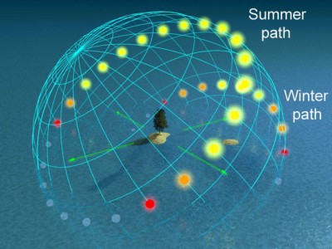
The path the sun takes in the sky is caused by the tilt of Earth's axis (see diagrams below). In summer, the sun rides high and days are long; in winter its path is much closer to the horizon and days are short.

At the Arctic Circle, that invisible circle of latitude at 66.5 degree north, the sun won’t even bother to rise on the solstice. North of there, the sun remains below the horizon longer and longer until we reach the North Pole, where it hasn’t shown its face since the fall equinox and won’t return until the first day of spring.
As you’re probably well aware, the South Pole experiences the exact opposite season.
While we relish our precious allotment of daylight here in the North, Antarctica researchers are enjoying the midnight sun on what for them and the rest of the southern hemisphere is the summer solstice.

The date of solstice varies because of the time zone you’re in and because a full revolution of the Earth around the sun takes 365 1/4 days rather than a nice neat 365. That quarter day is the reason we have to add a leap day every four years to our calendar – as we did in 2012 – otherwise the dates of the seasons would drift. Without leap days, after only 100 years, the calendar year would be 25 days ahead of the seasonal year, making the winter solstice begin in mid-January. We don’t want that to happen.
Still that extra 1/4 day and leap year days cause the seasonal start dates to vary by several days over a cycle of 400 years. The combined gravitational effects of the planets on Earth also cause a slight shifting of the season starts over centuries of time. Precession , which is the small cyclical wobble of the Earth’s axis caused by the gravitational attraction of the sun and moon on our planet’s equatorial bulge, also plays a part. Put it all together and the date of winter’s start can vary from December 20 to December 23. The outer dates – 20th and 23rd – are rare compared to the 21st and 22nd. The last Dec. 23 solstice occurred in 1903; the next happens in 2303. The next December 20 solstice won’t be until 2080. You can read more about the seasons and Earth’s orbit HERE.
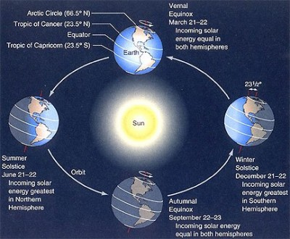
Of course the changes of season are NOT caused by Earth’s varying distance from the sun but by the 23.5 degree tip of its axis. During winter, the northern hemisphere is tipped away from the sun, making it appear much lower in the sky with shorter days the consequence. Less sunlight means colder temperatures and snow instead of rain. In summer the situation is reversed and days are long and hot.
The tip of Earth's axis causes the northern hemisphere in winter to face away from the sun and toward it in summer. Credit: NASA

The winter solstice, a time of darkness but simultaneously holding the hope of returning light, never fails to bring out mankind’s party spirit. We string lights, put green trees in our homes, sing around the blazing bonfire and beat drums. Many towns across the world hold winter solstice celebrations.

